How to Log in to the Park View Virtual Meet and Greet

Step 1  Open Chrome | 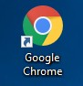
Step 2  In the address bar, type in www.portsk12.com (Note – the www must be included) | 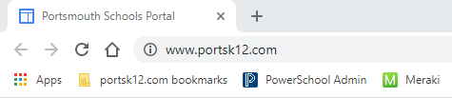
Step 3  Click where it says “Please click here to sign in” | 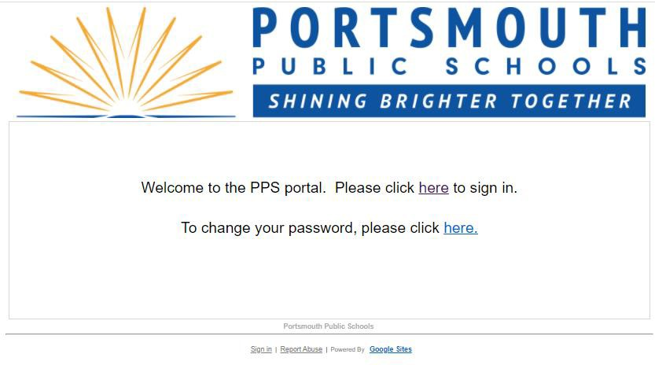
Step 4  Use the student’s credentials to sign in  (Note – the User name is simply firstname.lastname  – do NOT include the @portsk12.com with the  User name) | 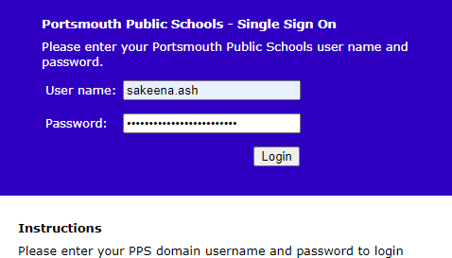

Step 5  After logging in to the Portsmouth Public Schools Portal, navigate to the address bar and type in clever.com/in/pps | 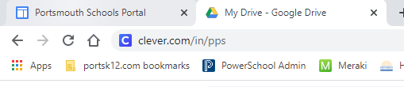
Step 6  Click the option to Log in with Google  (Note – if you do not follow steps 1-4 before accessing the Clever website, when you get to this step and select log in with Google, you will have to enter firstname.lastname@portsk12.com for the email address, then you will be directed back to step 4) | 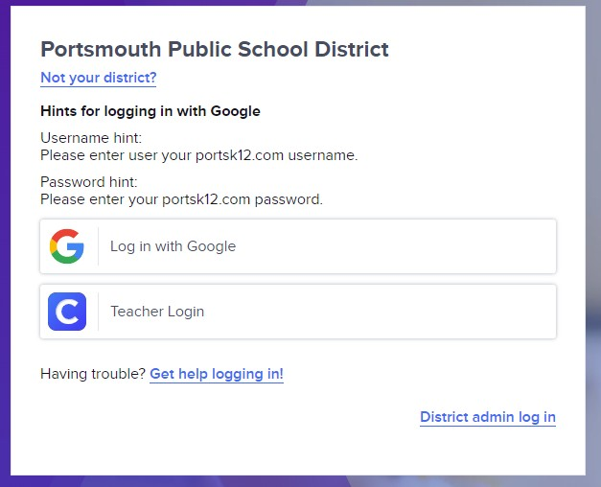
Step 7  You have successfully logged in to Clever and can access many of the resources available in the district | 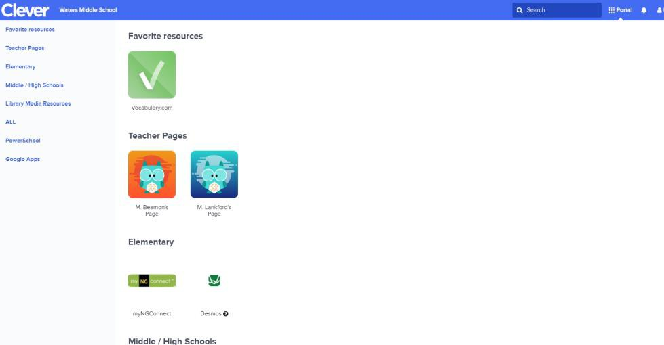
Step 8  Select Schoology and enter the information provided. There you will have access to the Zoom link. Or, simply click on the link from this page and you will be entered into the virtual classroom. | Your Virtual Teacher ENTER YOUR NAME HERE  Teacher’s Zoom Link ENTER YOUR ZOOM LINK  Schoology Access Code ENTER CLASS CODE HERE
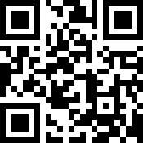
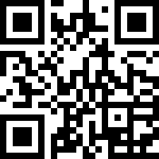
Scan this Code for the PPS Portal Scan this Code for Clever

